***COMSATS UNIVERSITY***

**WAH CAMPUS**

***Submitted By***

***Name:*** *Shayan Babar*

***Registration No:***  *Fa19-Bcs-051*

***Class/Section:*** *BSCS/6D*

***Submitted To***

***Teacher Name: Dr Majid Mumtaz***

***Date of Submission: 07-06-2022***

# Applying user login using Gmail

# Creating project

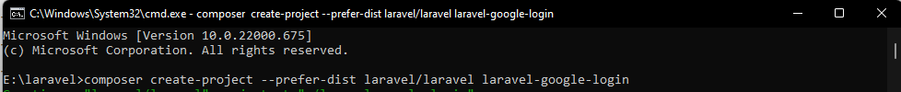

# Database allocation

# Install Sociallte package

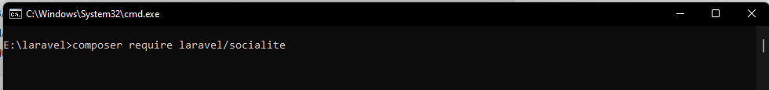

# add aliese and providers in **config/app.php**.

# Configure Google Credentials in Laravel

Will update this later on

# Get Secrets from google

A model will pop up use it in env file for security reason I have hidden then with red lines

# Make Auth

composer require laravel/ui –dev

php artisan ui bootstrap –auth

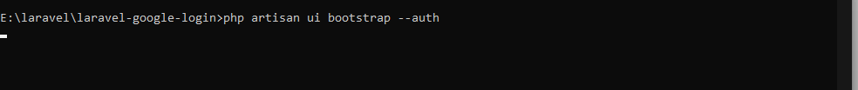

npm install && npm run dev

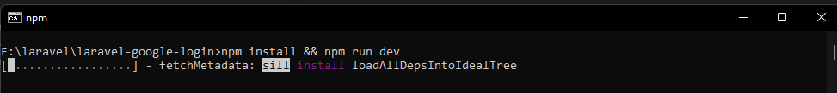

Optional for me I had to run

npm install resolve-url-loader@^5.0.0 --save-dev --legacy-peer-deps

# Add Column in users table

# Migrate

# Create Controller

# Routes

# Now open views/auth/register.blade.html to add google sign up link

Same in login.blade.html

# Php artisan serve

Also for me I had to add the following

Currently one user is added manually

# Now lets register using gmail

When u click register page following pops up

Select account working

